runfile('C:/Users/Eswar/.spyder-py3/temp.py', wdir='C:/Users/Eswar/.spyder-py3')

No X1 transaction date ... X6 longitude Y house price of unit area

0 1 2012.917 ... 121.54024 37.9

1 2 2012.917 ... 121.53951 42.2

2 3 2013.583 ... 121.54391 47.3

3 4 2013.500 ... 121.54391 54.8

4 5 2012.833 ... 121.54245 43.1

[5 rows x 8 columns]

No ... Y house price of unit area

count 414.000000 ... 414.000000

mean 207.500000 ... 37.980193

std 119.655756 ... 13.606488

min 1.000000 ... 7.600000

25% 104.250000 ... 27.700000

50% 207.500000 ... 38.450000

75% 310.750000 ... 46.600000

max 414.000000 ... 117.500000

[8 rows x 8 columns]

Estimated Intercept is -11419.108541125448

Coefficients of the model: [ 5.69398052 -0.24659966 -0.00573286 1.21839887]

features coefficients

0 X1 transaction date 5.693981

1 X2 house age -0.246600

2 X3 distance to the nearest MRT station -0.005733

3 X4 number of convenience stores 1.218399

Mean Absolute Error: 5.263881107555163

Mean Squared Error: 41.420529982747624

Root Mean Squared Error: 6.435878338094003

Variance score:0.74

Actual Predict Diff

200 25.5 35.249266 -9.749266

249 15.0 2.550654 12.449346

413 63.9 54.565347 9.334653

211 43.5 42.994350 0.505650

250 30.0 40.252396 -10.252396

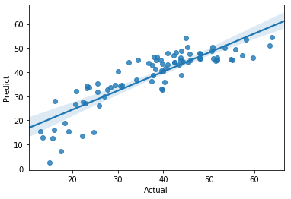

print(result_lm)

Actual Predict Diff

200 25.5 35.249266 -9.749266

249 15.0 2.550654 12.449346

413 63.9 54.565347 9.334653

211 43.5 42.994350 0.505650

250 30.0 40.252396 -10.252396

.. ... ... ...

346 30.8 34.612029 -3.812029

25 27.0 30.028526 -3.028526

243 48.2 45.736868 2.463132

390 38.6 46.432300 -7.832300

293 42.5 44.202484 -1.702484

[83 rows x 3 columns]